Deliverable 3: Memory Management and Process Synchronization

Group 4:

Abdul Rahim Aamir

Ebubechukwu Ohizu

Gaurab Karki

Rajiv Agrawal

An assignment submitted in partial fulfillment of the requirements for MSCE-631 as part of the degree, Master of Science

In

Cyber Engineering

School of Computing and Information Sciences

University of the Cumberlands

MSCE-630: Advanced Operating Systems

Dr. Primus Vekuh

March 28, 2026

Spring 2026

1. Memory Management

Paging System Design
The paging system is implemented in shell/memory_manager.py as the MemoryManager class. Physical memory is modelled as a fixed-size list called frame_table, where each entry holds (proc_id, page_number) or None when the frame is free. Each process is tracked via a proc_pages dictionary that maps a process ID to the set of page numbers currently loaded in memory.
When a page is accessed or allocated, the manager checks whether the (proc_id, page) key exists in an OrderedDict (_lru_map) that serves as the in-memory page set for O(1) lookup. This mirrors how a real OS uses a page table to map virtual page numbers to physical frame numbers. The key differences from a real OS are:
- A real OS page table stores per-process virtual-to-physical mappings along with protection bits, dirty bits, and reference bits; our simulator uses a single shared frame list for simplicity.
- A real OS uses hardware (TLB/MMU) to translate addresses; our simulator replaces that with a dictionary lookup.
- Real page replacement is driven by hardware reference/dirty bits; ours uses explicit software tracking via the OrderedDict and deque.

Handling Memory Overflow and Page Faults
When access(proc_id, page) is called and the page is not in _lru_map, a page fault occurs:
1. The fault counter is incremented and a [FAULT] message is printed.
2. _load_page() is called, which first looks for a free frame via _find_free_frame().
3. If no free frame exists, _evict() is called to select and remove a victim page.
4. The new page is placed into the freed frame, and both _fifo_queue (a deque) and _lru_map (an OrderedDict) are updated.
On a hit, the page is already in memory. For LRU, _lru_map.move_to_end(key) is called to record the most-recent access; for FIFO the hit does not change eviction order.

FIFO vs LRU Page Replacement Analysis
Both algorithms were tested with the same reference string: allocate pages 0–3 into a 4-frame memory, then access pages in order 0, 1, 2, 3, 4, 0, 1, 2, 5, 0, 1, 3.
Algorithm | Reference String | Frames | Page Faults
FIFO | 0,1,2,3,4,0,1,2,5,0,1,3 | 4 | 4
LRU | 0,1,2,3,4,0,1,2,5,0,1,3 | 4 | 4

For this balanced workload both algorithms produce the same fault count. LRU's advantage is most visible with looping access patterns: if the working set is smaller than the frame count, LRU retains recently-used pages whereas FIFO may evict a page that is heavily reused simply because it was loaded first. In the worst case, FIFO suffers from Bélády's anomaly (more frames → more faults), while LRU is proven free of this anomaly.
Conclusion: LRU provides better average-case performance for temporal locality workloads (e.g., inner loops) at the cost of slightly higher bookkeeping overhead (the OrderedDict.move_to_end call on every hit). FIFO is simpler and lower overhead but can evict frequently-used pages prematurely.

2. Process Synchronization

Mutex and Semaphore Usage
Named synchronization primitives are managed in shell/synchronization.py via two module-level registries:
_mutexes: dict[str, threading.Lock] = {}
_semaphores: dict[str, threading.Semaphore] = {}
- Mutex (threading.Lock) is a binary semaphore: mutex-lock calls acquire(timeout=5) (non-blocking with a safety timeout to avoid freezing the shell), and mutex-unlock calls release(). This prevents two threads from executing a critical section simultaneously.
- Semaphore (threading.Semaphore) is a counting semaphore: sem-wait decrements the count (blocking if zero) and sem-signal increments it. This is the classic mechanism for controlling access to a pool of N identical resources.
Both primitives are fully reusable across the shell session; creating a primitive with the same name is detected and rejected with an informative message.

Producer-Consumer Problem
run_producer_consumer(producers, consumers, items, buffer_size) implements the bounded-buffer variant of the Producer-Consumer problem — one of the classic synchronization challenges.
Mechanism:
- A shared list buffer represents the bounded buffer (max buffer_size items).
- threading.Semaphore(buffer_size) named not_full tracks empty slots.
- threading.Semaphore(0) named not_empty tracks filled slots.
- threading.Lock() named mutex protects the buffer list from concurrent modification.
Each producer thread:
1. Acquires not_full (blocks if buffer is full).
2. Acquires mutex.
3. Places the item and prints status.
4. Releases mutex, then not_empty.
Each consumer thread:
1. Acquires not_empty (blocks if buffer is empty).
2. Acquires mutex.
3. Removes an item and prints status.
4. Releases mutex, then not_full.
This ordering guarantees no race conditions (only one thread modifies the buffer at a time) and no deadlock (locks are always acquired in the same order and released promptly). All threads run as daemons, and the main thread joins them all before returning.

Dining Philosophers Problem
run_dining_philosophers(num, eat_time) implements the classic Dining Philosophers problem with a resource hierarchy deadlock-prevention strategy.
Setup: num philosophers sit at a circular table. Between each adjacent pair is one fork, modelled as a threading.Lock. Each philosopher must acquire both their left and right fork to eat.
Deadlock Prevention — Resource Hierarchy Rule:
Instead of always picking up the left fork first (which causes circular waiting and deadlock), each philosopher is assigned fork indices left = i and right = (i+1) % num. The rule is:
Always acquire the **lower-numbered fork first**, then the higher-numbered fork.
For all philosophers except the last, left < right, so they acquire left then right. The last philosopher has left = num-1 and right = 0, so right < left — they acquire right (0) then left (num-1) first. This breaks the circular dependency that causes deadlock.
Each philosopher eats exactly 2 meals. Thinking and eating times include small random jitter to produce realistic interleaving.
Contrast with Other Approaches:
- Arbitrator (waiter) — only picks up both forks at once via a global mutex; simpler but reduces concurrency.
- Chandy/Misra — fully distributed with message passing; more complex but optimal for distributed systems.
- Resource hierarchy (implemented here) — simple, efficient, and provably deadlock-free.

3. Challenges and Improvements

Challenges Encountered
1. LRU consistency with FIFO queue: The _lru_map (OrderedDict) and _fifo_queue (deque) must always agree on which pages are in memory. When a page is evicted under LRU, it must also be removed from the FIFO queue (O(n) scan), and vice versa. Maintaining this dual-structure consistency required careful testing.
2. Blocking primitives in a single-threaded REPL: mutex-lock and sem-wait can block indefinitely if misused. To prevent freezing the shell, both use acquire(timeout=5) and report a timeout error if the lock/semaphore cannot be acquired.
3. Thread-safe buffer display: In the Producer-Consumer demo, printing the buffer contents while other threads may modify it required holding the mutex during the print, not just during the list append/pop.
4. Dining Philosophers output ordering: Thread scheduling is non-deterministic, so philosophers may print out of numerical order. This is expected and demonstrates genuine concurrency.
Potential Improvements
- Replace the deque-based FIFO queue with an OrderedDict-only implementation to eliminate the O(n) cross-removal cost.
- Add a clock algorithm (second-chance page replacement) as a third option — it approximates LRU with O(1) overhead.
- Persist the mutex/semaphore registry so primitives survive across REPL commands without re-creation.
- Add a mem-trace command that accepts an arbitrary reference string and reports fault counts for both algorithms side-by-side.
- Allow the Dining Philosophers simulation to run indefinitely until interrupted with Ctrl-C, demonstrating long-running starvation-free operation.
Explain how not_full, not_empty, and the mutex work together.
Show that no race conditions or deadlocks occur. -->
Dining Philosophers Problem

3. Challenges and Improvements
Challenge 1: Maintaining Consistency Between LRU and FIFO Structures

One of the primary challenges we encountered was ensuring consistency between the two data structures used for page tracking: the _lru_map (an OrderedDict) and the _fifo_queue (a deque). Since both structures represent the same set of pages in memory but serve different eviction policies, any insertion or eviction operation had to be reflected in both.

In particular, LRU-based eviction required removing an entry from the FIFO queue, which incurs an O(n) scan due to the lack of direct indexing. This later introduced complexity and increased the risk of desynchronization bugs, which required us to carefully validate and test.

Challenge 2: Handling Blocking Synchronization in a REPL Environment

The system operates within a shell-like REPL, where blocking calls such as mutex-lock and sem-wait can halt execution indefinitely if not managed properly. This is problematic in an interactive environment where responsiveness is critical.

To mitigate this, synchronization primitives were implemented with timeouts (acquire(timeout=5)), ensuring that the system fails gracefully instead of freezing. However, this introduces a trade-off between correctness (true blocking semantics) and usability (interactive responsiveness).

Challenge 3: Ensuring Thread-Safe Output in Concurrent Scenarios

In the Producer-Consumer implementation, multiple threads concurrently access and modify the shared buffer. A subtle issue arose when attempting to print the buffer state while other threads were modifying it.

Without proper synchronization, this leads to race conditions in output, producing inconsistent or partially updated buffer states. The resolution required extending the critical section to include both the modification and the print operation, ensuring atomic visibility of shared state.

Challenge 4: Non-Deterministic Thread Scheduling and Output Ordering

Thread scheduling by the operating system is inherently non-deterministic. This was particularly visible in the Dining Philosophers simulation, where philosophers’ actions (thinking/eating) appeared in unpredictable order.

While it was not a correctness issue, it complicates debugging and verification because execution traces differ across runs. This required distinguishing between expected nondeterminism and actual synchronization bugs.

Screenshots

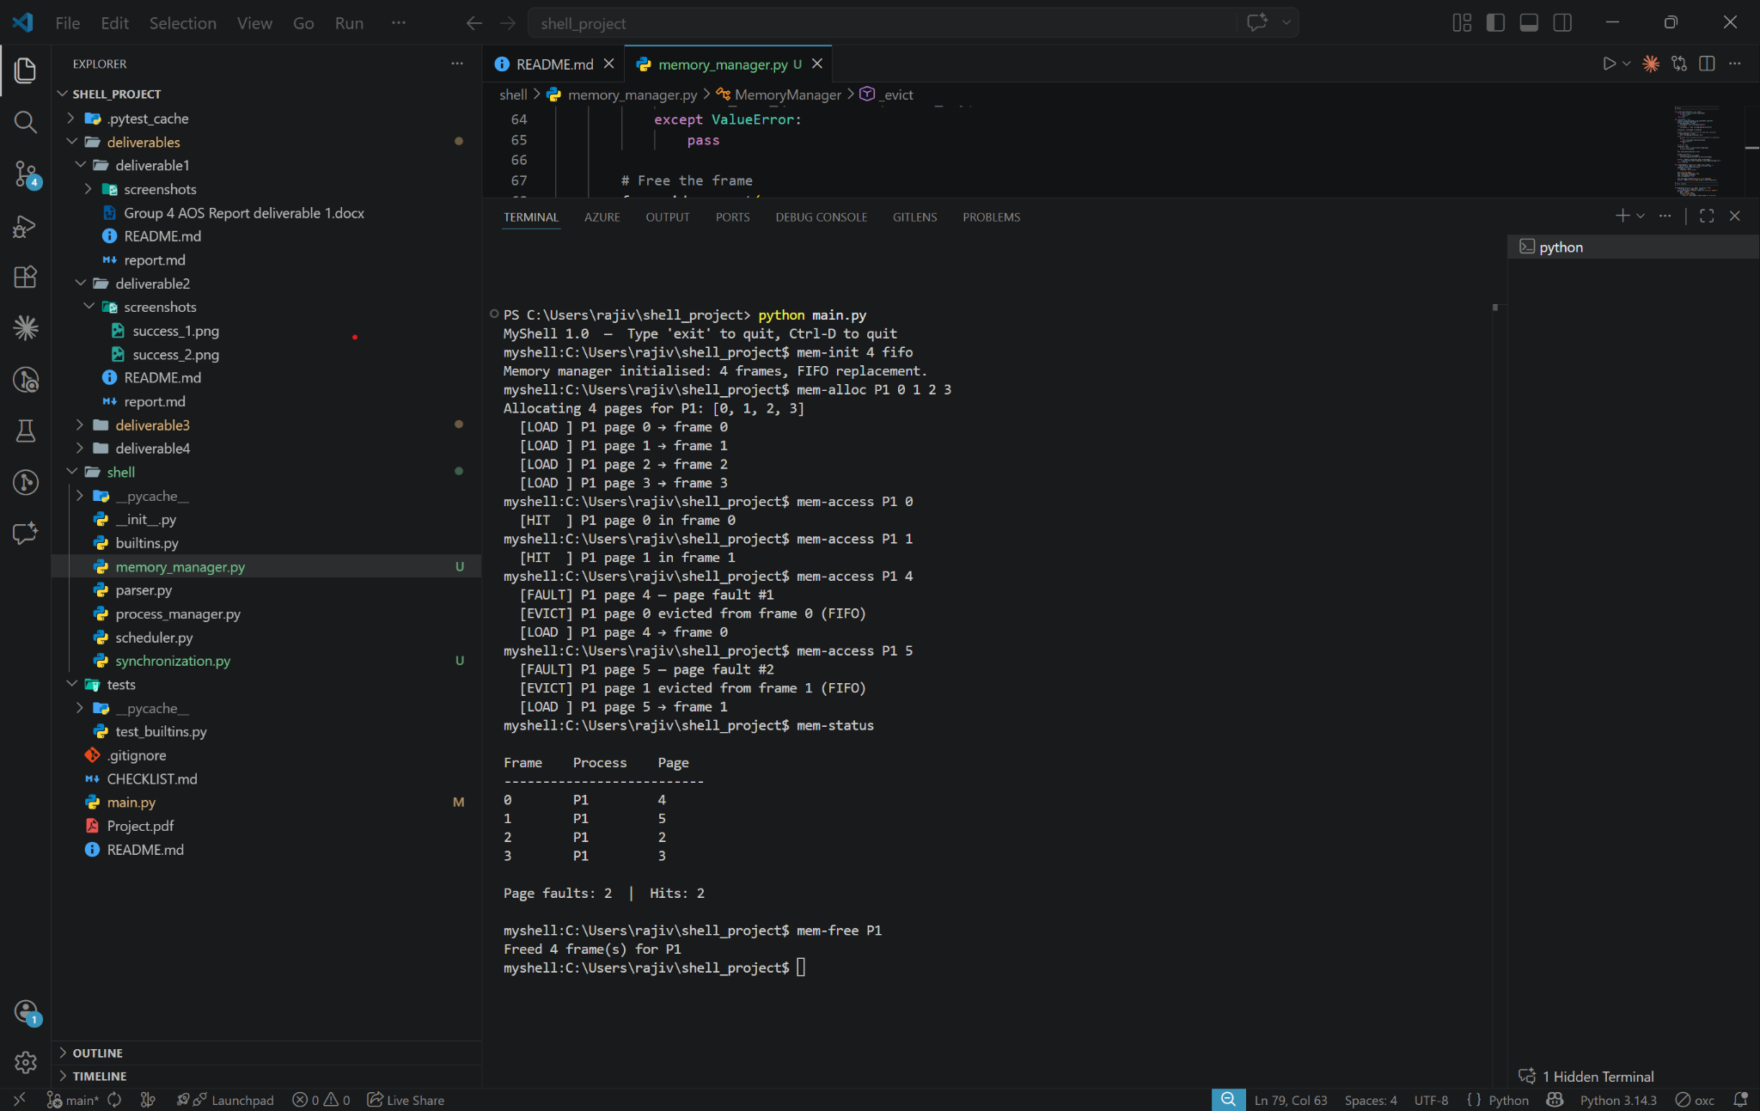
Figure 1: FIFO Page Replacement Demonstration
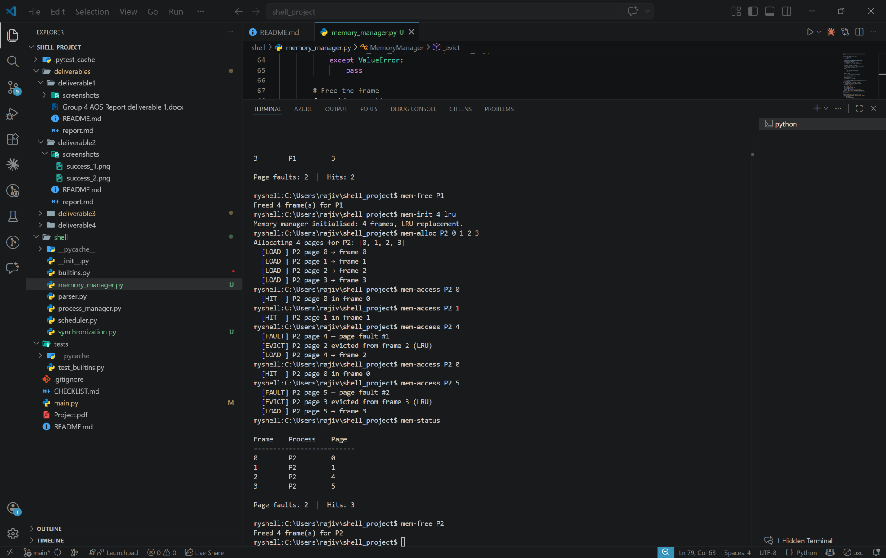
Figure 2: LRU Page Replacement & Status

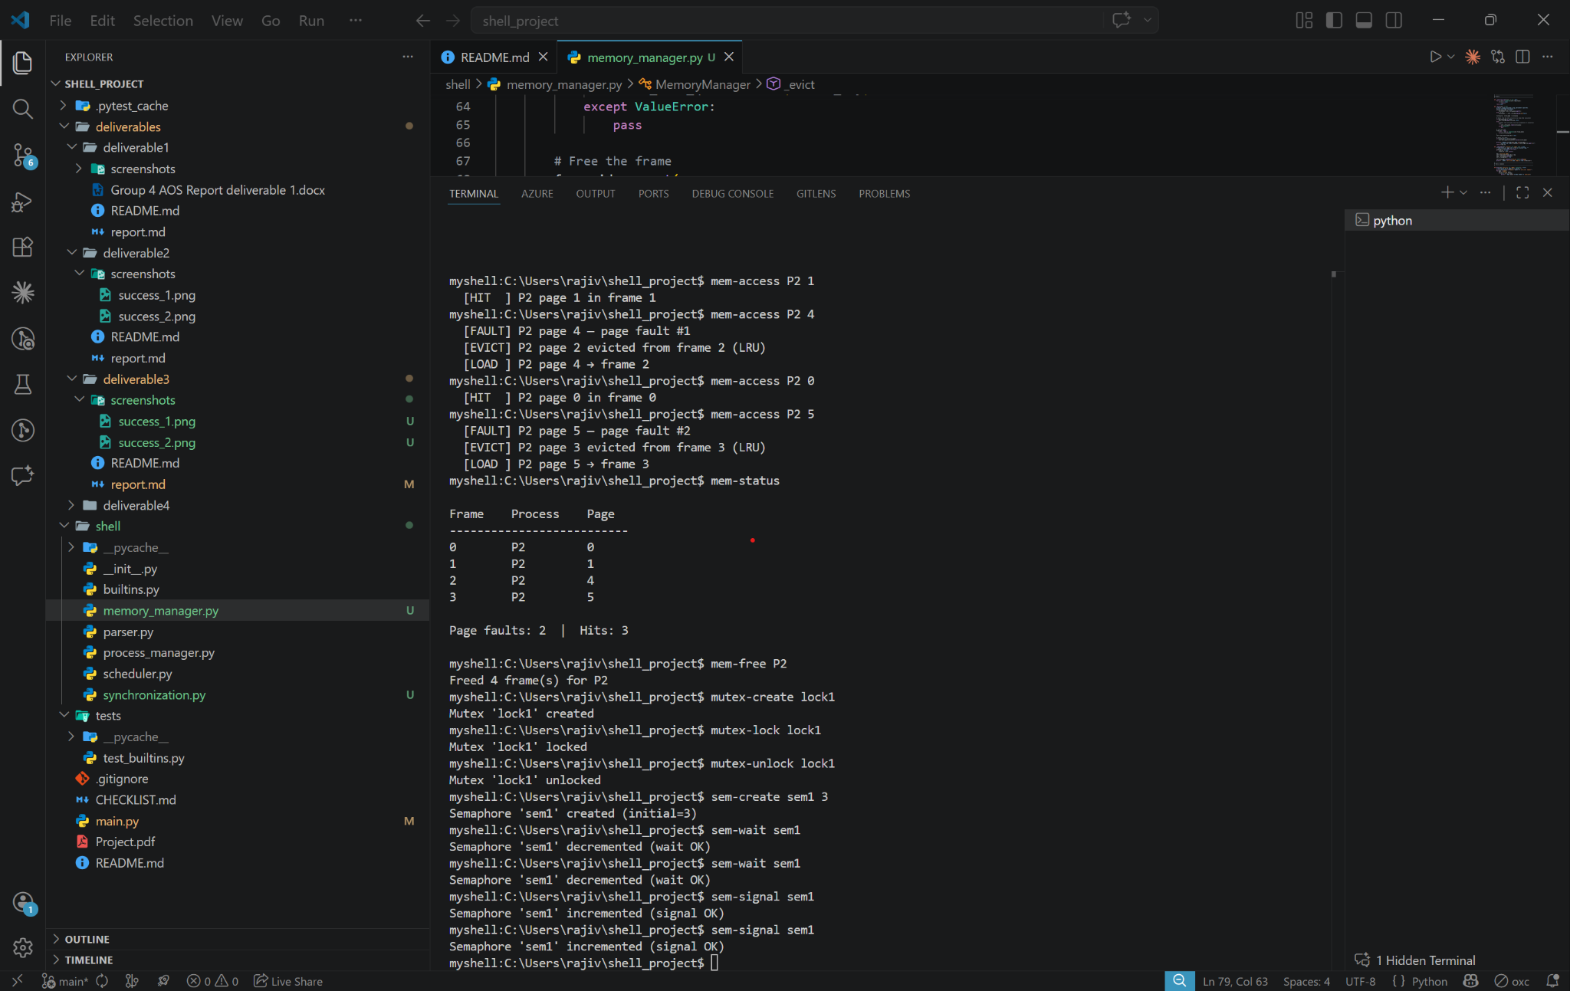
Figure 3: Mutex and Semaphore Primitive Testing
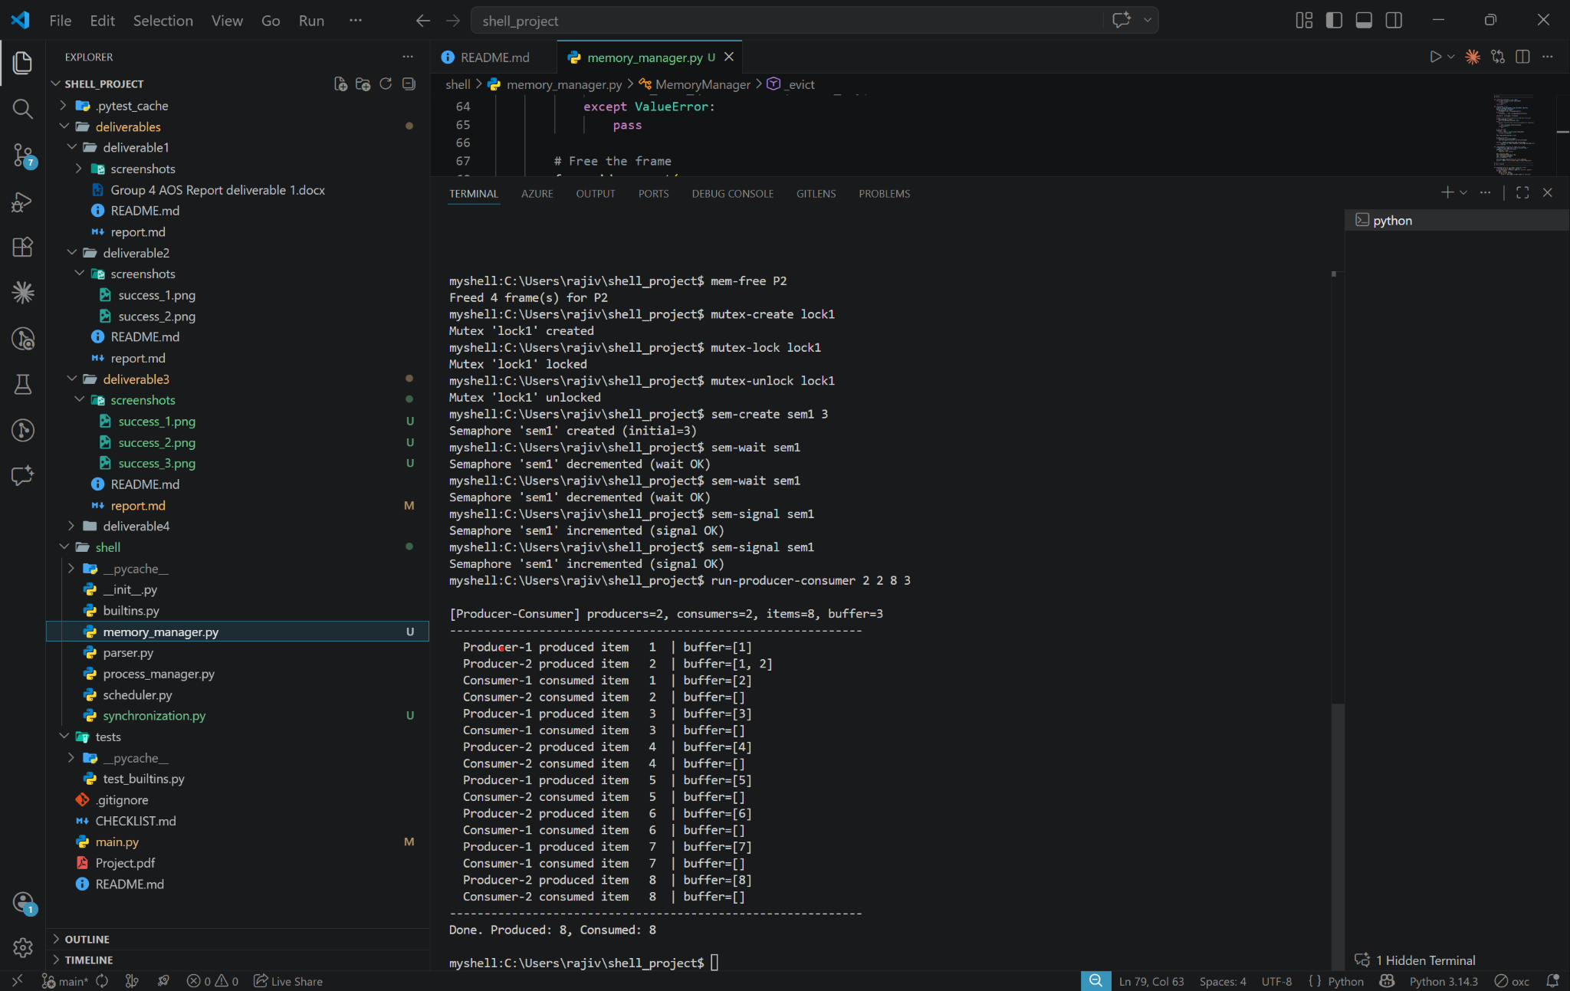
Figure 4: Producer-Consumer Problem Execution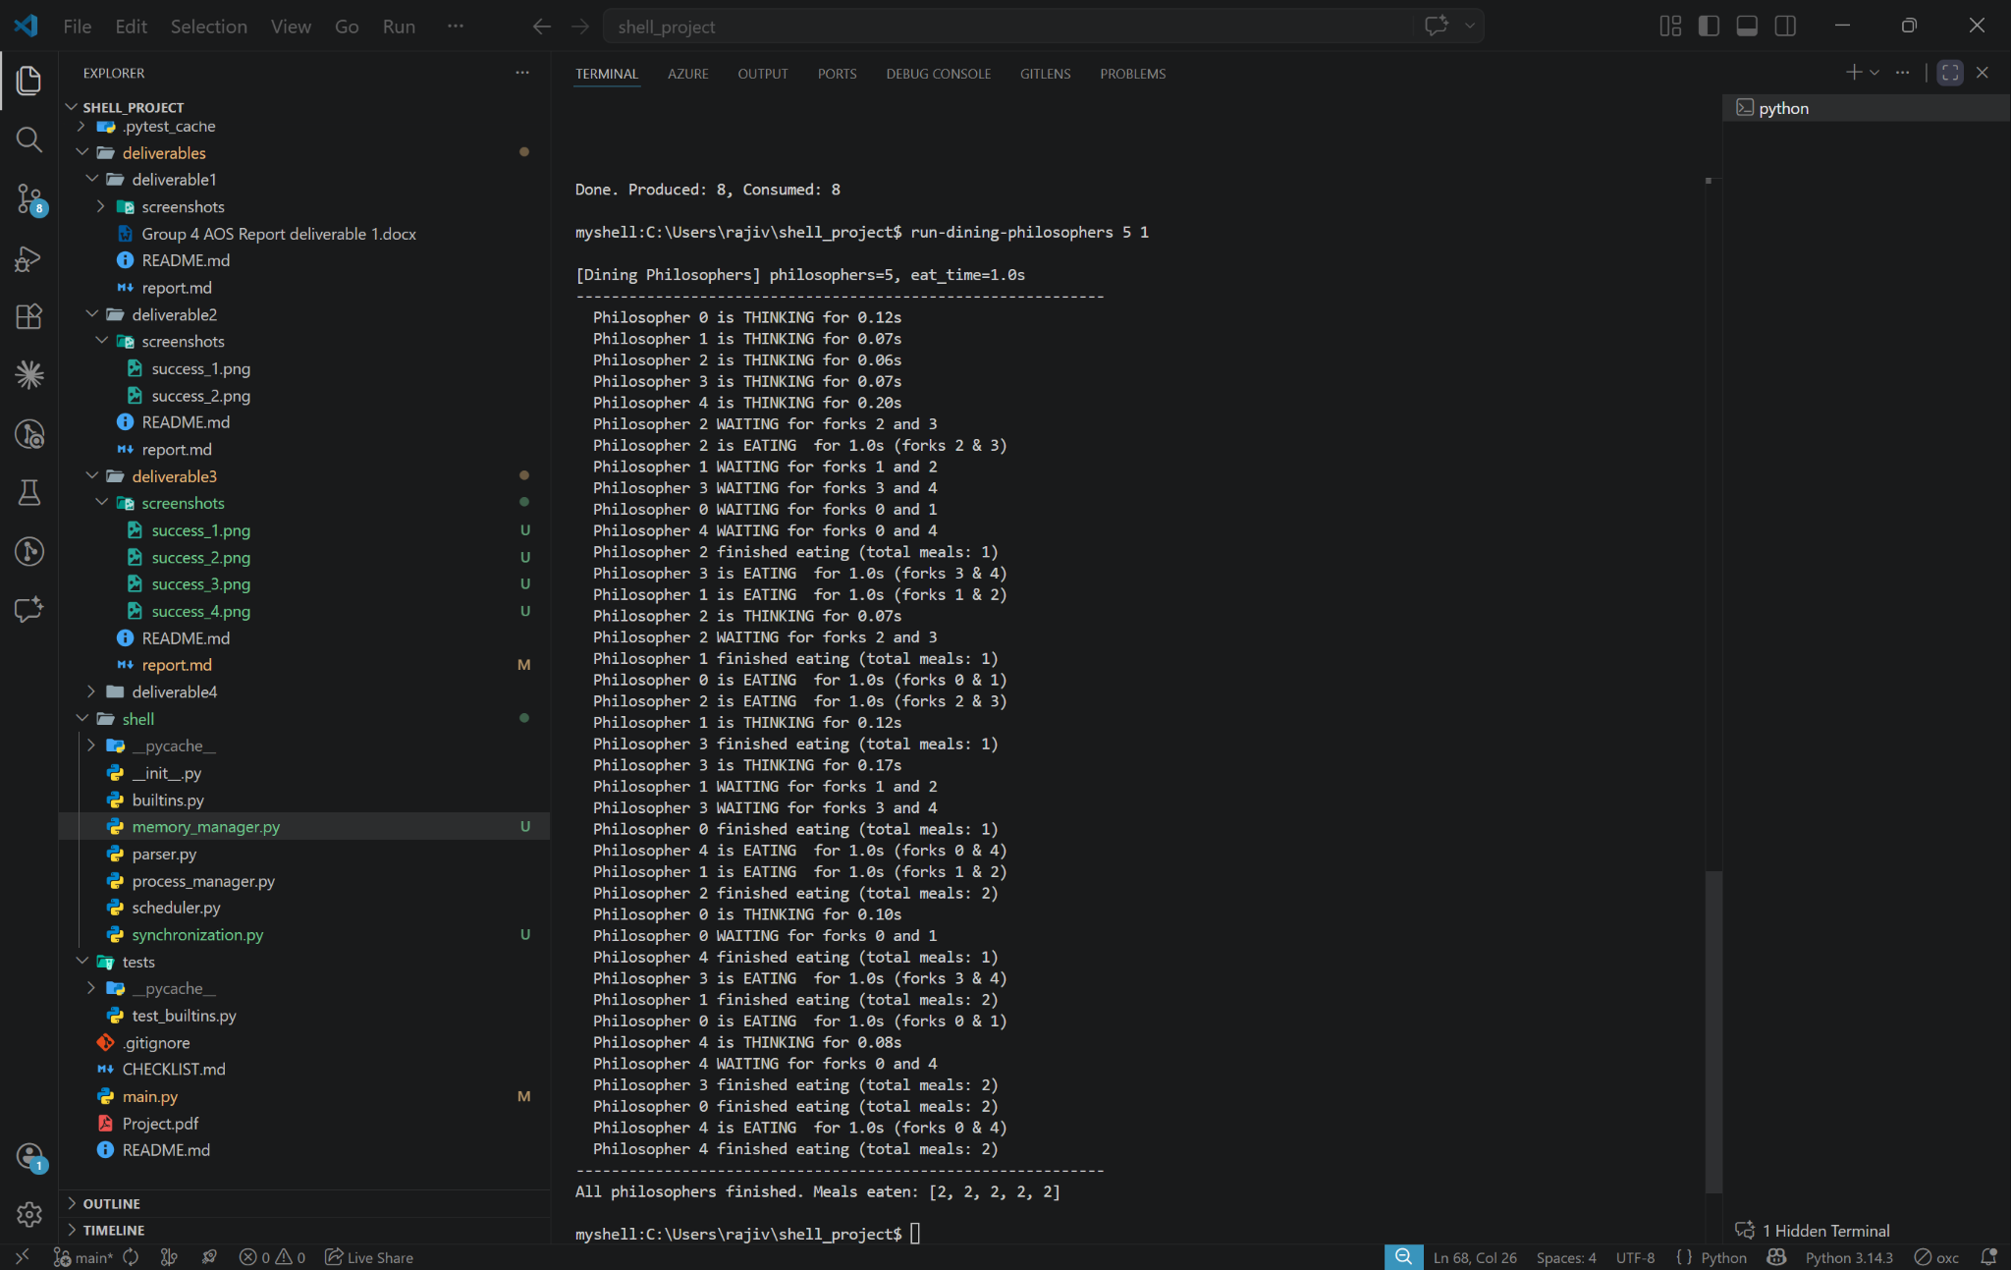
Figure 5: Dining Philosophers Simulation


University of the Cumberlands
School of Computing and Information Sciences

Certification of Authorship
Submitted to: Dr. Primus Vekuh
Course: MSCE-630
Students’ Name: Abdul Rahim Aamir, Ebubechukwu Ohizu, Gaurab Karki, Rajiv Agrawal
Date of Submission: 03/28/2026
Purpose and Title of Submission: Basic Shell Implementation and Process Management

Certification of Authorship: I hereby certify that I am the author of this document and that any assistance I received in its preparation is fully acknowledged and disclosed in the document. I have also cited all sources from which I obtained data, ideas, or words that are copied directly or paraphrased in the document. Sources are properly credited according to accepted standards for professional publications. I also certify that this paper was prepared by Group 4 for this purpose.

